**DEPARTMENT OF COMPUTER & SOFTWARE ENGINEERING**

**COLLEGE OF E&ME, NUST, RAWALPINDI**

**Subject Name**

**Digital Image Processing**

**Lab Number**

**6**

**SUBMITTED TO:**

**Dr. Asad Khan**

**LE Sundas Ashraf**

**SUBMITTED BY:**

**Student Name**

1. Wahaaj Nasir

**Reg#413238**

**DE- 44 Dept C&SE**

**Objectives:**

Filtering on Images and Histogram Calculations

**Related Topic/Chapter in theory class:**

Spatial Filtering

**Hardware/Software required:**

Hardware: PC

Software Tool: Pycharm

**Task 1:**

**Write a program that thresholds the provided image (Threshold_Image.png) using global mean and median.**

**Solution:**

import numpy as np  
import cv2 as cv  
  
def lower_by_x(image, thresh):  
 rows, cols = image.shape  
 new_image = np.ones((rows, cols), dtype=np.uint8)  
  
 for i in range(rows):  
 for j in range(cols):  
 if (image[i][j] >= 0 and image[i][j] <= thresh):  
 new_image[i][j] = 0  
 elif (image[i][j] >= thresh+1 and image[i][j] <= 255):  
 new_image[i][j] = 255  
  
 return new_image  
  
*#Main*image = cv.imread("D:/Uni/Semester 6/DIP/Self/Lab/Lab 6/Lab 6/Threshold_Image.png", 0)  
mean = np.mean(image)  
median = np.median(image)  
  
mean_thresh = lower_by_x(image, mean)  
median_thresh = lower_by_x(image, median)  
  
cv.imshow("Original Image", image)  
cv.imshow("Mean Thresholding", mean_thresh)  
cv.imshow("Median Thresholding", median_thresh)  
cv.waitKey()

**Output:**

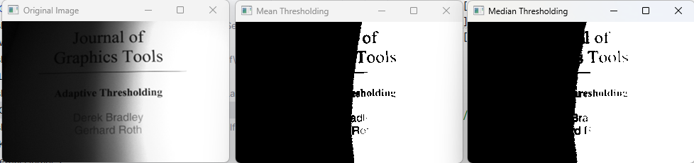

**Task 2:**

**Now threshold the same image by taking threshold value mean and median of 3x3 block locally.**

**Solution**

import cv2 as cv  
import numpy as np  
  
def padding(pad, orig):  
 rows, cols = orig.shape  
 padded_arr = np.ones((rows+ 2 * pad, cols+ 2 * pad), dtype = np.uint8)*255  
  
 for i in range(rows):  
 for j in range(cols):  
 padded_arr[i+pad][j+pad] = orig[i][j]  
  
 return padded_arr  
  
def remove_padding(padded_img, pad):  
 rows, cols = padded_img.shape  
 return padded_img[pad:rows-pad, pad:cols-pad]  
  
def local_thresh_mean(image, filter_size):  
 pad = filter_size//2  
 rows, cols = image.shape  
 filtered_img = np.zeros((rows, cols), dtype = np.uint8)  
  
 padded_img = padding(pad, filtered_img)  
 for i in range(pad, rows-pad):  
 for j in range(pad, cols-pad):  
 sub_img = image[i-pad:i+pad+1, j-pad:j+pad+1]  
 mean_val = np.mean(sub_img)  
 if(image[i][j] <= mean_val):  
 padded_img[i][j] = 0  
 else:  
 padded_img[i][j] = 255  
  
 filtered_img = remove_padding(padded_img, pad)  
  
 return filtered_img  
  
def local_thresh_median(image, filter_size):  
 pad = filter_size//2  
 rows, cols = image.shape  
 filtered_img = np.zeros((rows, cols), dtype = np.uint8)  
  
 padded_img = padding(pad, filtered_img)  
 for i in range(pad,rows-pad):  
 for j in range(pad, cols-pad):  
 sub_img = image[i-pad:i+pad+1, j-pad:j+pad+1]  
 median_val = np.median(sub_img)  
 if(image[i][j] <= median_val):  
 padded_img[i][j] = 0  
 else:  
 padded_img[i][j] = 255  
  
 filtered_img = remove_padding(padded_img, pad)  
  
 return filtered_img  
  
*#Main*image = cv.imread("D:/Uni/Semester 6/DIP/Self/Lab/Lab 6/Lab 6/Threshold_Image.png", 0)  
mean_img = local_thresh_mean(image, 3)  
median_img = local_thresh_median(image, 3)  
  
cv.imshow("Original Image", image)  
cv.imshow("Mean Thresholding", mean_img)  
cv.imshow("Median Thresholding", median_img)  
cv.waitKey()

**Output:**

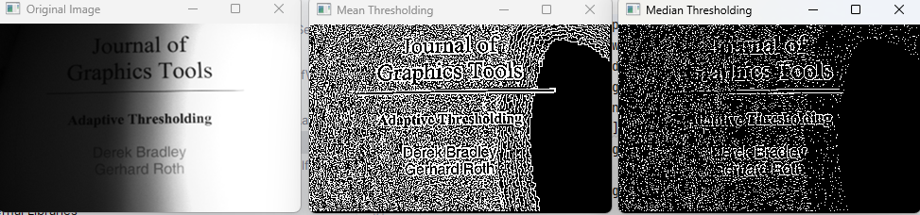

**Task 3:**

**Write a function that takes hematological image as input and segments the image using K mean clustering with and k=2. Write the function such that the k value can be passed as a parameter. Display the resulting image**

**Solution**

import cv2 as cv  
import numpy as np  
import math  
  
  
def initial_centroids(image, k):  
 unique_values = np.unique(image)  
  
 init_centroids = np.random.choice(unique_values, k, replace=False)  
 return np.array(init_centroids, dtype=np.uint8)  
  
  
def assign_cluster(image, centroids):  
 rows, cols = image.shape  
 labels = np.zeros((rows, cols), dtype=np.uint8)  
  
 for i in range(rows):  
 for j in range(cols):  
 min_dist = float('inf')  
 close_cluster = -1  
  
 for index, centroid_intensity in enumerate(centroids):  
 distance = abs(int(centroid_intensity) - int(image[i][j]))  
  
 if distance < min_dist:  
 min_dist = distance  
 close_cluster = index  
  
 labels[i][j] = close_cluster  
  
 return labels  
  
  
def update_centroids(image, labels, k):  
 new_centroids = []  
  
 for cluster in range(k):  
 cluster_points = image[labels == cluster]  
  
 if len(cluster_points) == 0:  
 new_centroids.append(0)  
 else:  
 new_centroid = np.mean(cluster_points)  
 new_centroids.append(new_centroid)  
  
 return np.array(new_centroids, dtype=np.uint8)  
  
  
def k_clustering(image, k, tolerance):  
 centroids = initial_centroids(image, k)  
 rows, cols = image.shape  
  
 while True:  
 labels = assign_cluster(image, centroids)  
 new_centroids = update_centroids(image, labels, k)  
 print("In this loop")  
  
 converge = True  
 for i in range(len(centroids)):  
 distance = abs(centroids[i] - new_centroids[i])  
 if distance > tolerance:  
 converge = False  
 break  
  
 if converge:  
 break  
  
 centroids = new_centroids  
  
 segmented_image = np.zeros((rows, cols), dtype = np.uint8)  
 for cluster in range(k):  
 segmented_image[labels == cluster] = int(255 / (k - 1)) * cluster  
  
 print(np.unique(segmented_image))  
  
 return segmented_image  
  
  
*# Main*image = cv.imread("D:/Uni/Semester 6/DIP/Self/Lec/Assignment 1/dataset_DIP_assignment/train/images/003.bmp", 0)  
segmented_image = k_clustering(image, 3, 0)  
  
cv.imshow("Original Image", image)  
cv.imshow("K Means Segmentation", segmented_image)  
cv.waitKey()

**Output:**

